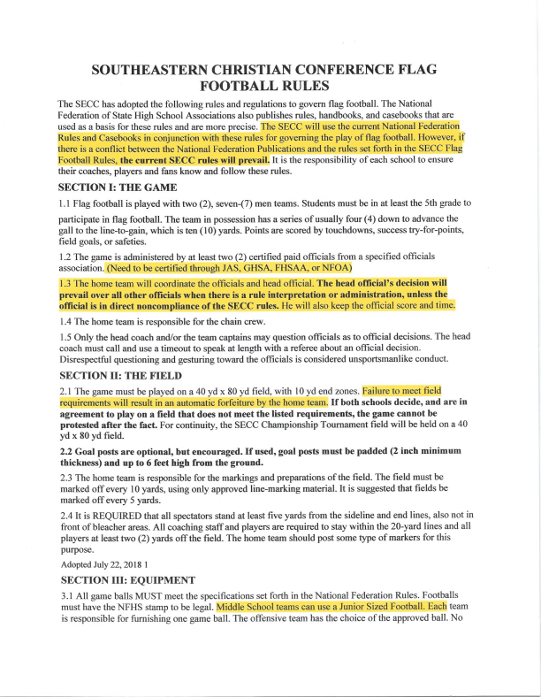
sticky or foreign substance may be added to the ball, bands or gloves such that would give a receiver an unfair advantage for catching the ball. Altering equipment will result in team forfeiture.
3.2 The home team is responsible for furnishing down markers and 10-yard yardage chain.
3 .3 The home team is responsible for furnishing the timing device. This will be the official time and an official on the field will keep it.
SECTION IV: PLAYER EQUIPMENT
4.1 Each player on the team shall wear a jersey of the same color and numbered on both the back and front.
Numbers on the back shall be at least six ( 6) inches high and on the front at least four ( 4) inches high. Jerseys must remain tucked in at all times and may not blouse over the top of the pants/belt.
4.2 All players shall wear "Triple Threat" flag belts as specified by SECC. Flags and belts must not be altered in any manner. Altering flags in any way are considered willful uns_eortsmanlike conduct (player will be ejected and the team assessed a IO-yard penalty.) '1'he belt must be worn about the waist. Flags must be at the hip and tail. Players must wear belts of appropriate size to ensure the proper location of the flags on the player's body.
Typically, these should run down the seam of legs on the pants. Players may not have towels stuck in their belt and/or ants for hand cleaning.
4.3 Players must wear the correct shoes at all times. They must be rubberized soccer or football cleats or regular athletic shoes. No metal cleats or spikes are allowed.
4.4 Sweat bands on wrists and bead are acceptable, but must match the unifo rm's predominate color. No hats or helmets are allowed.
4.5 No soft or hard protective equipment (such as pads) may be worn by a player. 4.6 Players are to wear matching, color-coordinating socks as part of their uniforms. Players may not have
mismatched socks. If a player does so, they will not be allowed to play until they meet the designated team uniform requirement. The styles of socks may have some variation as long as the color is the same.
4.7 Football players must wear football pants or baseball pants that do not have pockets. Must have inertnal belt. If the pants were made with pockets, they must be completely sewn shut, so as to avoid injury. Pants and flags must contrast in color. No shorts may be worn.
4.8 Team uniforms (jersey/shirt, pants, and socks) must match.
4.9 Belts must be the triple threat style.
SECTION V: THE TEAMS
5 .1 A team shall consist of seven (7) players on the field at one time. A team may start a game with six (6)players, but no less, and may continue with five (5) players. Any smaller number of players for these two situations will constitute forfeit.
Adopted July 22, 2018 2
5 .2 The offense must have at least three (3) players on the line of scrimmage. The defense must have at least three (3) players on the rush line.
5.3 One or two players must be designated as the team captain(s) by the coach.
5 .4 The coach is the official representative of the team and is responsible for seeing that the team complies with these rules.
SECTION VI: THE GAME
6.1 The varsity game consists of ( 4) IO-minute quarters, and there will be l minute break between each quarter. The middle school game consists of(4) 8-minute quarters. The middle school games will have a time limit of 1 hour and 30 minutes. If a middle school team is in the process of a drive down the field, the team will be allowed to finish the drive. ALL games will NOT be a running clock. Teams shall change directions at the end of the 1st and 3rd quarters, with a one-minute time out between quarters. Approximately four ( 4) minutes before the end of each half, an official will notify the coaches and team captains of the time remaining. If the score is 30 points or more difference the losing coach at half-time can make the decision to have a running clock for the remainder of the game. If the score is 30 points or more at the end of the third quarter the fourth quarter will be a running clock no exceptions. _{Weather Delays:} + A middle school game is called when there is more then (l) weather delay called by the official. If the
game has not reached halftime, the game must be rescheduled as a full, official game. If the game is called during the 3rd quarter, we will revert back to the score at halftime to declare the winner. If the game is called in the 4^{t1}, quarter, we will revert back to the score at the end of the 3rd quarter to declare the wmner.
+ A varsity game is called when there are more then (2) weather delays called by an official. If the game has not reached halftime, the game must be rescheduled as a full, official game. If the game is called during the 3rd quarter, we will revert back to the score at halftime to declare the winner. If the game is called in the 4th quarter, we will revert back to the score at the end of the 3rd uarter to declare the winner.
6.2 Starting the Game: The normal kickoff shall be the 30-yard line. Other free kicks shall be the 20-yard line. The receiving team shall be no closer than 20 yards from the free kick line.
6.3 The clock stops for the following dead balls and resumes when the ball is legally snaQPed or a free kick is touched: his is NOT o tional. Failure to lay in accordance to the rules may result in forfeiture.
+ Team timeouts
+ Penalty delay of game
4- Incom lete Pass
+ Any score
rt Extra Points (The clock does not run at all during an extra point)
+ 2-Point conversions (The clock does not run at all during a 2-point conversion) + End of a period
+ Official time out
4- Ball out of bounds
6.4 The clock may be stopped for an official's time, and started again by the official's signal for the following reasons:
+ Measurement for first down
+ First down declared
+ Change of team possession
+ Notification of time remaining
+ Significant layer injury
+ Any unusual delay in getting ball in play or other similar reason Player equipment repair- If this is not fixed within 30 seconds, the coach will have to either call a timeout or send in a substitute until the e ui ment iIBp.ill!,e�pllied
6.5 The offense will have 25 seconds to put the ball in play after it has been spotted.
their bodies as shields/screens unless that offensive player is still, and upright. The offensive l!_layers cannot make a wall of any kind while moving, regardless of touching the defensive layer. The offensive players must be running a clearly defined route otherwise it is considered blocking.
6.27 Defensive players must go around an offensive player or screener at all times. Pushing, pulling, sliding across the screener, or going through or under a blocker is a defensive charging violation and a l 0- yard penalty. Defensive players are responsible to avoid bodily contact with a ball carrier at all times. Violation is a 10-yard penalty. A defensive player may jump into the five-yard neutral zone without an offsides penalty providing be is back out ofthe neutral zone before the ball is snapped. When the ball is within the 10-yard line or 4th down and the neutral zone is the football itself, a defensive player jumping offsides will result in an automatic offside penalty ( 5 yards or half the distance to the goal).
6.28 Pass interference: Offensive -A 10-yard penalty and loss of down from the point of the snap. Defensive -A 10-yard penalty from the point of the snap and an automatic 1st down for the offense. If interference was intentional and unsportsmanlike, an additional IO-yard penalty is added. If the ball does not cross the line of scrimmage, it is no interference. It may be a penalty or holding or unnecessary contact.
6.29 Spinning constitutes a 5-yard penalty from the point of infraction. Spinning is defined as an act that the ball carrier makes more than one (l) consecutive 360-degree tum. After one of his 360-degree turns, the ball carrier must move in an obvious forward direction without spinning or make a definite football move before beginning another spin. A ball carrier does not have to complete a spin of360 degrees. This does not restrict a ball carrier from twisting to avoid being down ed.
6.30 When a penalty flag has been thrown, play will continue until there has been a whistle or the ball is downed. The offended team will be notified as to their options. Officials are not obligated to warn either team by the head official prior to penalties for infractions ofthe rules.
6.31 Any profanity or unsportsmanlike conduct will result in the offender being removed from the game and/or field. The player's coach must be informed of the wrongdoing by the head official.
6.32 Any unsportsmanlike conduct of a gross and willful nature or fighting will result in the ejection of the offending player, coach, or spectator from the game and reported to the State Board. If a coach is ejected, he/she must submit a letter to the President stating the cause for the ejection within 24 hours. The head official will also submit a letter to the President within 24 hours. (See SECC By-laws 9.2.1)
6.33 Tie Breaker: Ifthe score is tied at the end ofregulation play, a coin toss will determine which team will choice of possession of the ball first. Each team will receive the ball on the I 0-yard line and given, four downs to score (They will also receive an attempt at the extra point or two-point conversion if a touchdown is scored). If the team with the ball throws an interception, their possession is over. At the end ofboth team's possessions, the team with the highest score wins. If both teams are still tied, another overtime is started. The team who loses the coin toss will have the choice if there is a need for a second overtime. The choice will alternate until the game is decided. This will go on until the tie is broken. A tie should always be broken if possible. The only reason a tie might not be broken is a lack of sufficient light to play. Ifa third overtime is required, the teams can no longer kick the extra point, but must go for two each time.
6.34 Any offensive player that has possession of the ball can extend his arms in order for him to reach a yard marker, or goal line. The offensive player's feet must be on the ground, or in a normal running otion during this action. When the offensive layer has the ball, they are not allowed to dive, or lea to reach a yard marker, or goal line.
SECTION VII: FORFEITS
7. l If a team fails to play at a scheduled time without proper notification to the other team, the game is forfeited in favor of the offended team. The score is 1-0 for the offended team, or if the offended team is ahead in the game, the score at the time of forfeit. If the offending team is ahead at time of forfeit, then it is 1-0 in favor of the offended team.
7 .2 Proper notification is at least 48 hours preceding the game. If it is possible earlier notification is requested.
7.3 Rescheduling of games is the responsibility of the teams and should be done as soon as possible. All rescheduled gªmes must be completed a minimum of two days before the State Tournament so the State Board will have ample time to bracket teams for the State Tournament.
7.4 The forfeiting school MUST give reason for the forfeit in writing to the school and the Conference President.
SOUTHEASTERN CHRISTIAN CONFERENCE SUMMARY OF PENAL TIES & FOULS
✓ Illegal use of hands and tackling by defense - 10 yards from end of run
✓ Stiff-arm, shielding, charging, diving, lowering head - 10 yards
✓ Blocking or illegal screening - 10 yards
✓ Offensive pass interference - 10 yards, loss of down
✓ Defensive pass interference - IO yards, 1st down
✓ Illegal contact with passer - 10 yards, 1st down
✓ Unsportsmanlike conduct- 10 yards
✓ Improper uniform or equipment- 10 yards
✓ Illegal participation - 10 yards
✓ Illegal pass or handling of the ball - 5 yards, loss of down
✓ Illegal spot pass on punts or kicks - 5 yards
✓ Intentional grounding of ball- 5 yards, loss of down
✓ Less than three (3) men on offensive line of scrimmage or defensive rush line - 5 yards ✓ Encroachment, off-sides, or false starts - 5 yards
✓ Illegal procedure - 5 yards
✓ Illegal snap - 5 yards
✓ Illegal spinning - 5 yards
✓ Delay of Game - 5 yards
✓ Illegal man in motion - 5 yards
✓ Detaching flag early- 5 yards, 1st down
Adopted June 16th, 2022

